Counting Dracula!

Count Dracula is having a Halloween party! He has bought some treats for the party.

Cut apart the boxes.
Then sort them into 2 piles.
One pile is for numbers greater than 10. The other pile is for numbers less than 10.

6 buckets of popcorn | 14 Cookies
#  15 sweets | 2 cakes
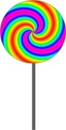  5 lollipops | 3 apples
16 cartons of juice | 24 monkey nuts
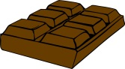  8 chocolate bars | 12 bunches of grapes

